**XMAS COURSES**

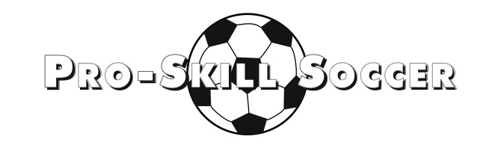

**COURSE 1 : Thursday 23rd December ( 1 day ).**

**COURSE 2. Thursday 6th & Friday 7th January ( 2 Days )**

**AGES: 4-12 YRS**

**COST: Course 1. - £20. Course 2. - £35.**

**TIMES : 9.30 AM – 3.00 PM**

**VENUE: Gresford Memioral Hall. ( INDOOR & OUTDOOR)**

Why not join the North West’s leading soccer school for an action packed soccer courses. The courses caters for Boys and Girls, whether your child is a beginner or star of the future, our programme is a great way of having fun, learning new skills and making new friends in a safe secure environment. All Pro-Skill Soccer coaching staff are fully qualified, insured and DBS cleared. For more details visit:

**THE DAY WILL INCLUDE OUR INFLATABLE DART BOARD AND OUR SUBUTEO INFLATABLE FOOTBALL PITCHES!!!!!**

To book your place simply fill in the slip below and send with payment of **£__ to Pro Skill Soccer, 36, Pant Olwen, Gresford, Wrexham, LL12 8ES**. Cheques should be made payable to: **Pro-Skill Soccer.**

**There will be a £10 discount for siblings ON COURSE 2.**

**PLEASE NOTE:** Limited spaces are available for these courses. Please make sure to send your slip with payment to reserve your child’s place ASAP.

All children will need to bring a packed lunch and drinks for the day. **All children will also need suitable clothing and footwear for Indoor football.**

**HOTLINE: 07732648043**

- - - - - - - - - - - - - - - - - - - - - - - - - - - - - - - - - - - - - - - - - - - - - - - - - - - - - - - - - - - - - - - - - - - -

Name: __________________________ Age: ________

Address: __________________________________________ Post Code: ______________

Contact Number: _______________________ School: _____________________________

Parent Name: ___________________________ Sign: _____________________________

Email Address: ______________________________

Any medical requirements should accompany this form in writing.