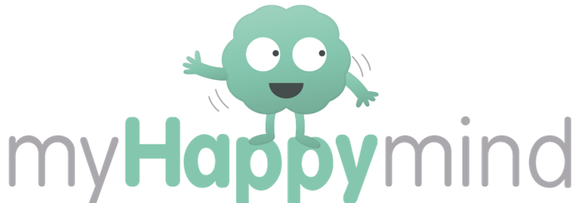

Annwyl Rieni a Warchodwyr Dear Parents and Guardians,

Rydym wedi cychwyn rhaglen Ysgol Gyfan i holl blant Bro Alun o’r enw ‘myHappymind’. Sefydlwyd y rhaglen hwn i helpu plant i ddechrau deall sut mae’r ymennydd yn gweithio a sut mae’r ymennydd yn gallu eu cynorthwyo i ddatblygu sgiliau ac arferion positif if od y fersiwn gorau ohonynt!

We have introduced a program to all year groups at school called myHappymind. myHappymind is all based around helping children to understand how their brain works and to support them in developing positive skills and habits to be their very best selves!

Athrawon dosbarth sy’n cyflwyno’r rhaglen ‘myHappymind’ yn yr ysgol trwy cyfres o weithgareddau rhyngweithiol, a wedyn mae cyfle i’r plant ymarfer eu sgiliau wedyn. I sicrhau mae digon o gyfleoedd i wreiddio’r dysgu hwn ac i chi fel rhiant i gymryd rhan yn y dysgu, mae ‘myHappymind’ wedi creu set o adnoddau i rieni hefyd. Gellir cael mynediad i’r adnoddau hyn ar gyfrifiadur neu ar eich ffôn trwy ap. Mae’r adnoddau yn rhoi’r cyfle i blant ymarfer y sgiliau ac arferion tu allan i’r ysgol, fel ‘Anadlu’n Hapus’, ac i chi cael gweld beth maent yn ei ddysgu yn y rhaglenni ysgol. Yn ogystal, mae gweithgareddau i chi wneud ar y cyd gartref efo’ch plentyn ac i gefnogi’r gwersi ysgol.

myHappymind is delivered in schools by class teachers through a series of interactive lessons and then the children apply these learnings throughout the day. To further embed this learning and ensure that you are able to engage in these topics with your child, myHappymind has developed a set of resources for parents. These resources can be accessed online on your computer, or through an app on your phone. The resources allow children to continue to practise some of the habits they have developed at school, such as Happy Breathing, for you to learn more about what they are learning in the program. Also included are activities for you to do together at home, to complement the in-school lessons.

I fewngofnodi’r adnoddau, ewch i https://myhappymind.org/parent-resources a rhowch eich enw, cyfeiriad ebost, a’r côd dilysu. Eich côd dilysu yw 402331

To access these materials just go to https://myhappymind.org/parent-resources and enter your name, email, and authentication code. Your authentication code is 402331
Neu sganiwch y côd QR hyn i gofrestru:

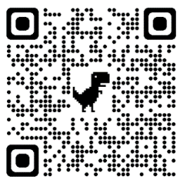
Or scan this QR code to sign up

Rydym yn awyddus iawn i chi wneud defnydd o’r adnodd yma sy’n ddi-gost er mwyn i chi gefnogi eich plentyn i gael y gorau o’u rhaglen. Os oes gennych unrhyw gwestiwn, mae croeso i chi gael sgwrs efo’ch athro’athrawes dosbarth.

We really encourage you to make use of this free content so that you can support your child in getting the best out of the programme. If you have any questions about the programme, please contact your class teacher.

Os oes gennych unrhyw gwestiwn technegol am yr adnoddau hyn, mae croeso i chi ebostio hello@myHappymind.org

If you have any technical questions about accessing the resources, please contact hello@myHappymind.org
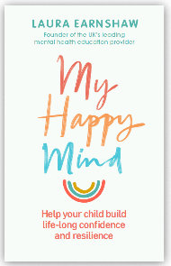
Hoffech wybod mwy? Dyma lyfr gan Laura Earnshaw a sylfaenodd y rhaglen ‘myHappymind’.

Want to learn more? Check out myHappymind founder Laura Earnshaw’s best selling book on Amazon.

Diolch. Many thanks.

